1. Get shipper’s Company Name for an order using inner join. (Display only orderID from orders and comapnayName from Customers table)

**Answer**

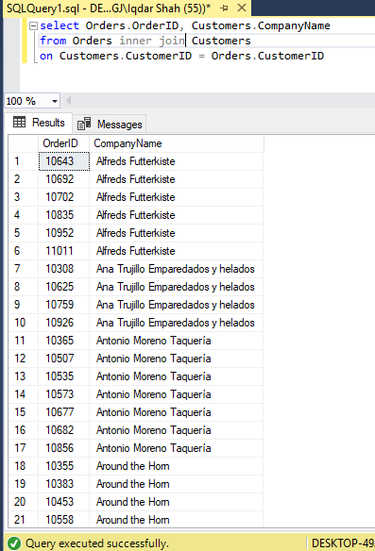

1. Display Product’s name and their supplier’s name (ContactName), whose supplier’s name doesnot contain Dirk and there should be at most 7 characters in Product’s name.

**Answer**

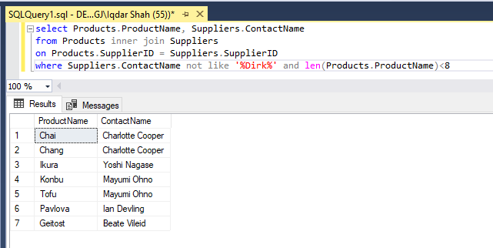

1. Create a report showing order ID. OrderDate. EmployeeID, and the firstname and LastName of the associated Employee (Tables: Employees & Orders )

**Answer**

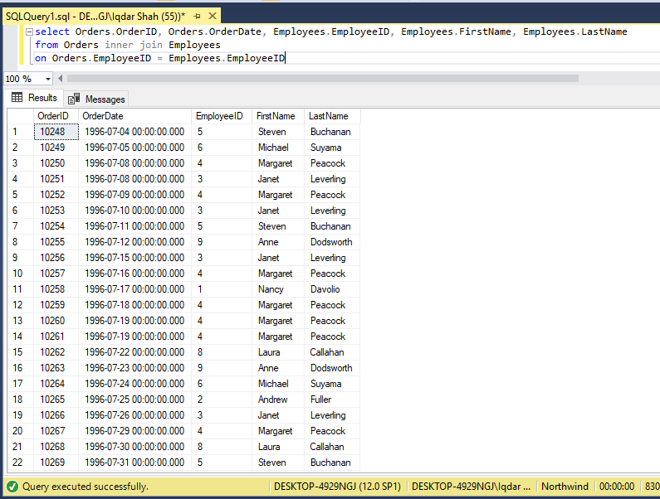

1. Count no of Products’s against each suppliers name. list only those products whose count is greater than 3.

**Answer**

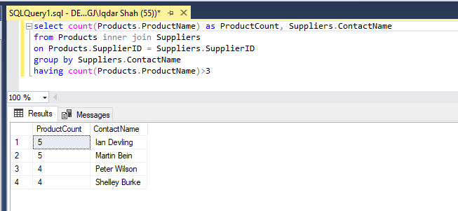

1. Display Region ID, Region Description, Territories Description and (inner join with table Territories and Region)

**Answer**

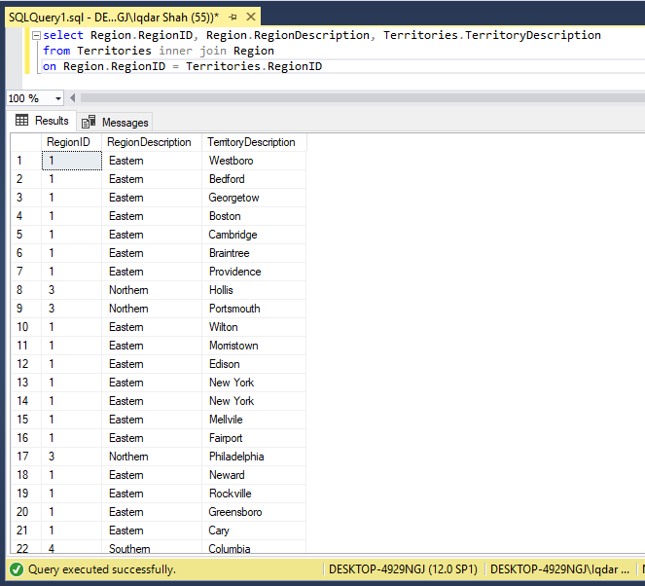

1. Display Company Name and Total orders placed by the company (Table: orders, customer, use inner join, group by)

**Answer**

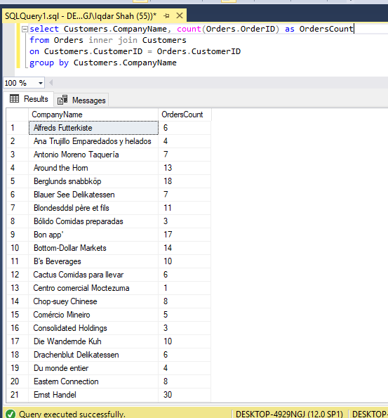

1. Display Product Name and its Category Name where Category Name starts with B (Hint: Left join category and product, use wild card)

**Answer**

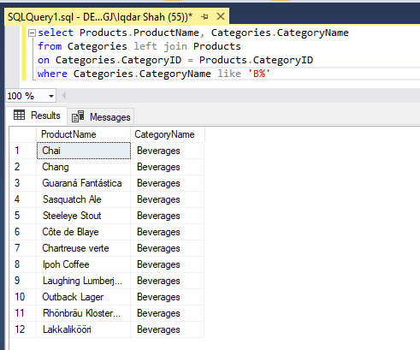

1. Display Titles and their quantity (Hint Pubs database, table title and sales, left join)

**Answer**

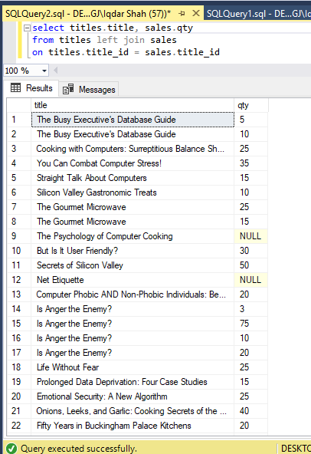

1. Use Right join to display Book Title and publisher Names (Hint pubs Database, Table Title and Publisher) Write down the reason for any null values if coming in title column.

**Answer**

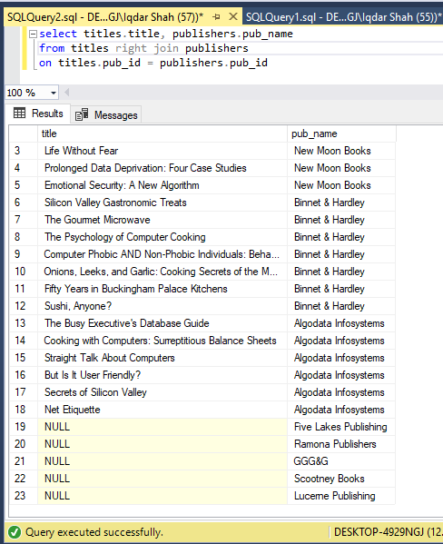

1. User Right join to display those publishers where title is null.

**Answer**

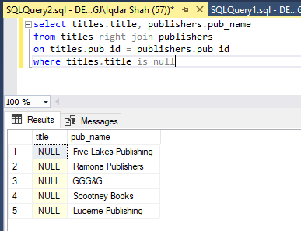

1. Use self-join to display Publishers name where city is same (Publisher id should be different) Sample example

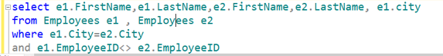

**Answer**

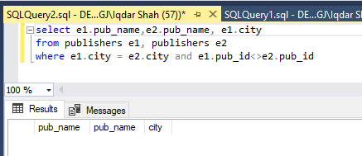

1. Use cross join (Cartesian join) to Display Book Title and Publisher Name.

**Answer**

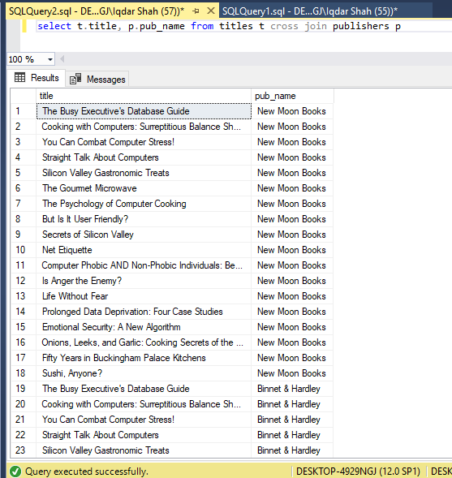

1. Use two full joins to Display Product Name, Category Name and Supplier Name (Hint: Below Example)

Example:

select col1 ,col2 ,col3

from table supplier

full join table product

on supplier.productid=product.productid

full join Categories

on product.CategoryID=category.CategoryID

**Answer**

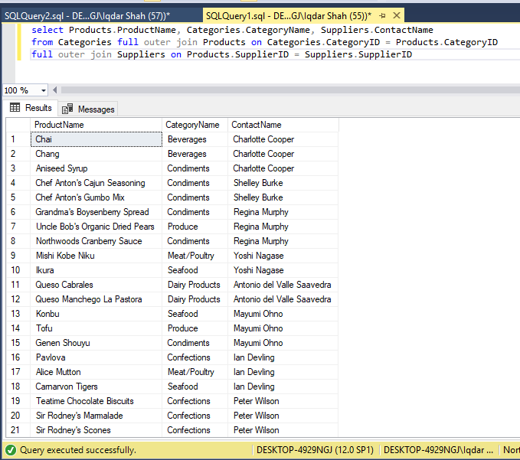

1. Use full join to display the name of Supplier for the product starting with letter C (Hint: Northwind)

**Answer**

